|  |
| --- |
| **CHAPTER** -5 |

**C Variables**

* Variable is the name of a memory location where we stores some data.
* We cannot declare a **variable** without specifying its **data type**. The data type of a variable can be int, float, char, depends on what kind of value we want to store in the variable and how much space we want it to hold.
* The name of variable can be changed.
* The name of variable is always meaningful .

Like int age =56;

The syntax for declaring a variable is simple:

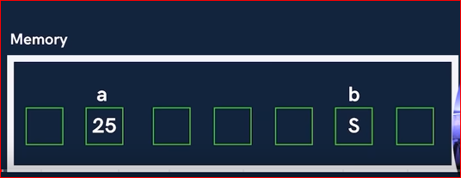

Here a and b is the name of memory location where we store the data. these name of memory location is called variable. (Real life example we store some food in different container and we need to provide some name of these container to identify which type of food stores in this container .the name of the container is called variable )

**The syntax for declaring a variable :**

We can declare and assign value to a variable in two ways.

***In First way to declare and assign value to a variable both  are in same time.***

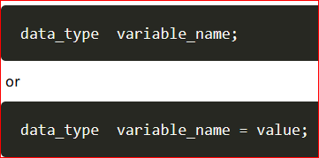

  int number = 7;

  char latter = 'c';

  float pi = 3.14;

  printf("number is =%d", number);

  printf("\n latter is =%c", latter);

  printf("\n value of pi is =%f", pi);

***In Second way first declare and  then assign value to a variable.***

***data_type  variable_name //  Declare a variable***

***variable_name = value // Assign a value to the variable***

  {

    int number;

    number = 7;

    char latter;

    latter = 'c';

    float pi;

    pi = 3.14;

    printf("\n number is =%d", number);

    printf("\n latter is =%c", latter);

    printf("\n value of pi is =%f", pi);

  }

**There are specific rules we must follow while naming a variable:**

* Variables are case sensitive. Means small a and capital A both are different variable.
* A variable name can contain alphabets, digits, and underscore (_) only. But first character of a variable name must be alphabet or underscores(_) .
* White spaces and comma cannot be used.
* The name should not be reserved keyword or special character.

#include<stdio.h>

int main()

{

*//First way to declare and assign value to a variable.*

*data_type  variable_name = value;*/*

    int number = 7;

    char latter = 'c';

    float pi = 3.14;

    printf("number is =%d",number);

    printf("\n latter is =%c",latter);

    printf("\n value of pi is =%f",pi);

*/*Second way to declare and assign value to a variable.*

*data_type  variable_name */*

    {

    int number;

    number = 7;

    char latter;

    latter = 'c';

    float pi;

    pi = 3.14;

    printf("\n number is =%d",number);

    printf("\n latter is =%c",latter);

    printf("\n value of pi is =%f",pi);

    }

      {

// RULES OF NAMING VARIABLE

*// 1.Variables are case sensitive means both are different variable small a and*

*capital A.*

         int a = 20;

         int A = 40;

         printf("\n print the value of a=%d \n  A=%d",a,A);

*/*2. A variable name can contain alphabets, digits, and underscore (-) only.*

*but first character of a variable name must be alphabet or underscore(_)*/*

        {

        int _age = 23;

        int ram_age = 89;

         printf("\n print the age of ram =%d \n %d",_age,ram_age);

        }

*/*3. White spaces and comma can not be used.*

*like this*

*int ram age;*

*int ram,age;*/*

*//•4. The name should not be reserved keyword or special character.*

      }

}